**TO: Sydney Central City Planning Panel**

**SUBJECT:** 14-16 Patricia Street MAYS HILL NSW 2145

**APPLICATION No:** DA2021/0636

|  |  |
| --- | --- |
| **Application accepted** | 16 November 2021 |
| **Applicant** | New South Wales Land and Housing Corporation |
| **Owner** | New South Wales Land and Housing Corporation |
| **Application No.** | DA2021/0636 |
| **Description of Land** | 14-16 Patricia Street MAYS HILL NSW 2145,  Lot 74 DP 13239, Lot 75 DP 13239 |
| **Proposed Development** | Demolition of existing structures and construction of a four storey residential flat building containing 29 affordable housing units over one level of basement parking pursuant to State Environmental Planning Policy (Affordable Rental Housing) 2009 |
| **Site Area** | 11,394m2 |
| **Zoning** | R4 High Density Residential Zone |
| **Disclosure of political donations and gifts** | Nil disclosure |
| **Heritage** | The site is not listed as heritage item and it is not located within Heritage Conservation Area. |
| **Principal Development Standards** | FSR  Permissible: 1.2:1 (+0.5:1 ARH SEPP bonus)  Proposed: 1.63:1  Height of Building  Permissible: 15m  Proposed: 14.3m |
| **Issues** | * Landscape area * Solar access to COS & units * Building separation/visual privacy * Size of ground floor private open space (POS) * Adaptable units and car parking |

SUMMARY

1. *Development Application No. DA2021/0636* *was accepted on 16 November 2021* *for the demolition of existing structures and construction of a four storey residential flat building containing 29 affordable housing units over one level of basement parking pursuant to State Environmental Planning Policy (Affordable Rental Housing) 2009**.*
2. *The application was publicly notified to occupants and owners of the adjoining properties for a period of 14 days between 3 December 2021* *and 17 December 2021**. In response, no submission was received.*
3. *The subject site is not listed as a heritage item or located within the heritage conservation area in the Holroyd Local Environmental Plan 2013.*
4. *The subject application has been assessed against the relevant provisions of the Environmental Planning and Assessment Act 1979, State Environmental Planning Policy No 65 – Design Quality of Residential Apartment Development and Apartment Design Guide (ADG), State Environmental Planning Policy (Affordable Rental Housing) 2009 (ARH SEPP), Cumberland Local Environmental Plan (CLEP) 2021 and Cumberland Development Control Plan (CDCP 2021).*
5. *The notable variations are as follows:*

|  |  |  |  |
| --- | --- | --- | --- |
| ***Control*** | ***Required*** | ***Provided*** | ***% variation*** |
| *Landscaped area*  *(ARH SEPP)* | *35m² per dwelling (1015m²)* | *551m²* | *45.7%* |
| *Communal Open Space*  *(ADG)* | *50% of COS receive 2 hours* | *139m² (39.8%)* | *10.2%* |
| *Solar access*  *ARH SEPP*  *ADG* | *70% - 3 hours*  *70% - 2 hours* | *31%*  *69%* | *39%*  *1%* |
| *Building separation (ADG)* | *6m* | *3m* | *50%* |
| *Ground floor POS (ADG)* | *15m²* | *10m²* | *33.3%* |
| *Adaptable unit and disabled car spaces (CDCP 2021)* | *6* | *4* | *33.%* |

1. *The owner of the subject property is NSW Land and Housing Corporation. Consequently, the application has been made on behalf of the Crown, and is defined as a Crown Development pursuant to Division 4.6 of the Environmental Planning and Assessment Act, 1979. The draft notice of determination provided at Attachment 1 to this report have been agreed to by the applicant.*
2. *The application is referred to the Panel as the proposal is a Crown development with capital investment value of over $5 million.*
3. *The application is recommended for approval subject to the conditions as provided in the attached schedule.*

**REPORT**

Subject Site and surrounding area

The subject site is known as 14-16 Patricia Street, Mays Hill and has a combined site area of 1,394m² and frontage of 30.54m. The legal description of the property is Lots 74 and 75 in DP13239. The site has a gradual slope of approximately 2m from west (rear) to east (front). The subject site is burdened by a 1.25m wide drainage easement along the southern boundary of 16 Patricia St. The property is currently occupied by two dwelling houses. Mature trees are located throughout the site. The subject site is zoned R4 – High Density Residential under the CLEP 2021.

The surrounding locality is in its early stages of transitioning from low to higher density development, which currently comprises a mix of low density residential dwelling houses and higher density residential flat buildings.

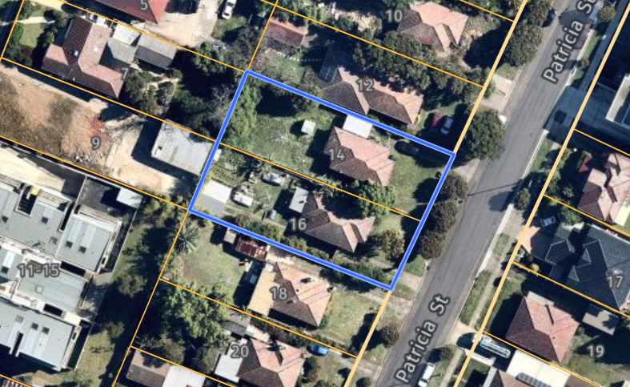

Figure 1 – Locality Plan (subject site edged in blue)

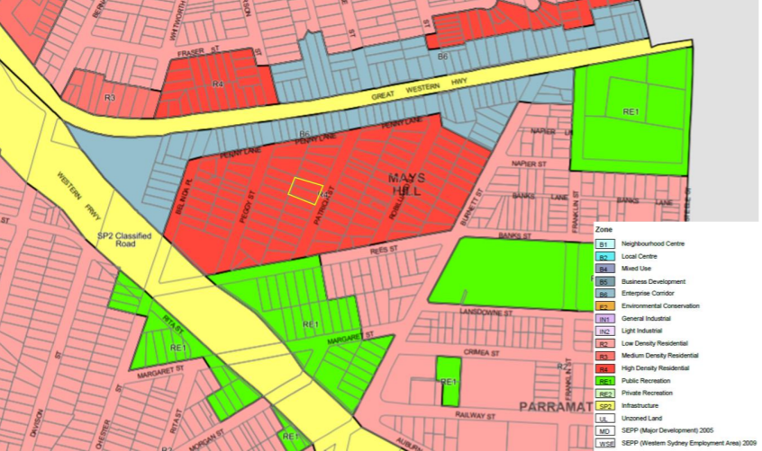

Figure 2 – Zoning Map (subject site edged in yellow)

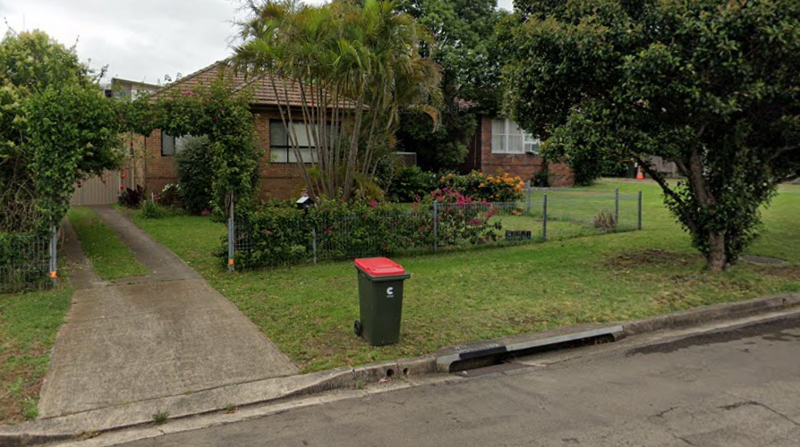

Figure 3 – Street view of subject site

Description of the development

Council is in receipt of development application for demolition of existing structures and construction of a four storey residential flat building containing 29 affordable housing units over one level of basement parking pursuant to State Environmental Planning Policy (Affordable Rental Housing) 2009.

The following is a summary of the proposed development:

* Demolition of existing dwellings and associated structures and tree removal;
* Construction of a four-storey residential flat building with 29 units, comprising;

13 x 1-bedroom units including one adaptable unit,

15 x 2-bedroom units including two adaptable units, and

1 x 3-bedroom adaptable unit.

* Basement parking for 14 cars, including 4 disabled spaces;
* Ground floor communal open space at the rear yard;
* Stormwater works;
* Landscaping and fencing; and
* Consolidation of two lots into one.

Key features of the development proposal are as follows:-

|  |  |
| --- | --- |
| **Level** | **Details** |
| Basement | 14 residential car spaces, including 4 disabled parking spaces  15 bicycle spaces  Storage, plant room, lifts and fire stairs |
| Ground floor level | 5 residential units  4 bicycle spaces  Communal Open Space  Waste and electrical rooms  Substation |
| Level 1 | 8 residential units |
| Level 2 | 8 residential units |
| Level 3 | 8 residential units |

The dwelling mix of the proposal is as follows:

- 13 x 1 Bed Unit (44.8%);

- 15 x 2 Bed Unit (51.7%); and

- 1 x 3 Bed Unit (3.5%).

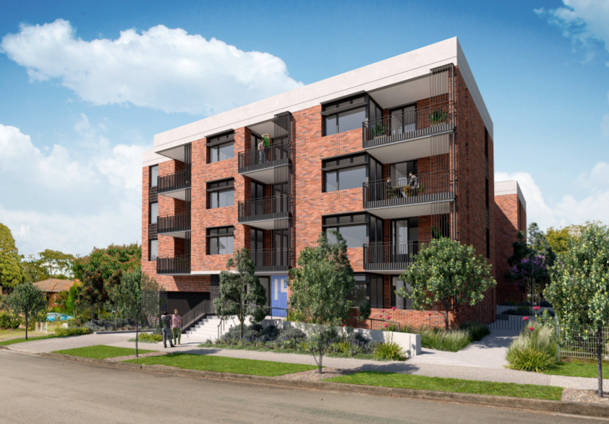

Figure 4 – Perspective of Development

History

Prelodgement meeting (PL2021/0071) held with the applicant on 20 July 2021 for demolition of existing dwellings and associated structures and construction of a 4 storey residential flat building comprising 33 units (17 x 1-bedroom and 16 x 2-bedroom units) and basement car parking for 15 car spaces.

The development application was lodged and accepted by Council on 16 November 2021.

Request of additional information was sent to the applicant on 20 December 2021, after the briefing with the Sydney Central City Planning Panel (the Panel) for the subject application on 14 December 2022. Additional information response was submitted to Council on 28 January 2022 and 7 March 2022.

Further briefing was held with the Panel on 3 February 2022 to discuss the status of the application and the non-compliances associated with the proposal. The Panel considers that both the architectural and landscaping design overall are contextually appropriate and satisfactory.

Applicants Supporting Statement

The applicant has provided a Statement of Environmental Effects prepared by Keylan Consulting Pty Ltd dated 4 November 2021 and was received by Council on 16 November 2021 in support of the application.

Contact with relevant parties

The assessing officer has undertaken a site inspection of the subject site and surrounding properties and has been in regular contact with the applicant throughout the assessment process.

Internal Referrals

*Development Engineer*

The development application was referred to Council’s Development Engineer for comment who has advised that the development proposal is satisfactory with regard to stormwater management and car parking and therefore can be supported subject to recommended conditions of consent.

*Environment and Health*

The development application was referred to Council’s Environment and Health Officer for comment who has advised that the development proposal is satisfactory regarding to noise impact and contamination and therefore can be supported subject to recommended conditions of consent.

*Tree Management Officer*

The development application was referred to Council’s Tree Management Officer for comment who has advised that the development proposal is satisfactory with regard to the trees removal and therefore can be supported subject to recommended conditions of consent.

*Waste Management*

The development application was referred to Council’s Waste Management Officer for comment who has advised that the development proposal is satisfactory regarding the proposed waste management and therefore can be supported subject to recommended conditions of consent.

External Referrals

*Endeavour Energy*

The development application was referred to Endeavour Energy for comment who has advised that the development proposal is satisfactory in terms of electricity connection and therefore can be supported subject to recommended conditions of consent.

*NSW Police*

The development application was referred to the NSW Police for comment. No response was provided within the required notification period.

Planning Comments

**The provisions of any Environmental Planning Instruments (EP&A Act s4.15 (1)(a)(i))**

1. **State Environmental Planning Policy (Planning System) 2021**

Development of a type that is listed in Schedule 6 of Planning System SEPP is defined as ‘regional significant development’. Such applications require a referral to a Sydney District Panel for determination as constituted by Part 3 of Schedule 2 under the *Environmental Planning and Assessment Act* 1979. The proposed development constitutes ‘Regional Development’ as it has a Capital Investment Value (CIV) which exceeds the $5 million threshold for Crown development. While Council is responsible for the assessment of the DA, determination of the Application will be made by the Sydney Central City Planning Panel.

1. **State Environmental Planning Policy (Resilience and Hazards) 2021**

Chapter 2 – Coastal Management

Not applicable. The subject site is not identified as a coastal wetland or ‘land identified as “proximity area for coastal wetlands” or coastal management area.

Chapter 4 – Remediation of Land

Clause 4.6 of Resilience and Hazards SEPP requires Council to be satisfied that the site is suitable or can be made suitable to accommodate the proposed development. The matters listed within Clause 4.6 have been considered in the assessment of the development application.

| **Matter for Consideration** | **Yes/No** |
| --- | --- |
| Does the application involve re-development of the site or a change of land use? | Yes  No |
| Does the application involve re-development of the site or a change of land use? | Yes  No |
| In the development going to be used for a sensitive land use (e.g.: residential, educational, recreational, childcare or hospital)? | Yes  No |
| Does information available to you indicate that an activity listed below has ever been approved, or occurred at the site?  acid/alkali plant and formulation, agricultural/horticultural activities, airports, asbestos production and disposal, chemicals manufacture and formulation, defence works, drum re-conditioning works, dry cleaning establishments, electrical manufacturing (transformers), electroplating and heat treatment premises, engine works, explosive industry, gas works, iron and steel works, landfill sites, metal treatment, mining and extractive industries, oil production and storage, paint formulation and manufacture, pesticide manufacture and formulation, power stations, railway yards, scrap yards, service stations, sheep and cattle dips, smelting and refining, tanning and associated trades, waste storage and treatment, wood preservation | Yes  No |
| Is the site listed on Council’s Contaminated Land database? | Yes  No |
| Is the site subject to EPA clean-up order or other EPA restrictions? | Yes  No |
| Has the site been the subject of known pollution incidents or illegal dumping? | Yes  No |
| Does the site adjoin any contaminated land/previously contaminated land? | Yes  No |
| Has the appropriate level of investigation been carried out in respect of contamination matters for Council to be satisfied that the site is suitable to accommodate the proposed development or can be made suitable to accommodate the proposed development? | Yes  No |
| Details of contamination investigations carried out at the site:  A search of Council’s records and a review of historical aerial imaging does not reveal any details that the site is contaminated. A targeted Detailed Site Investigation was prepared by Progressive Risk Management (ref: P035406.003 | C0385) dated 7 March 2022. Following a review of the targeted report, it was recommended that the site can be made suitable for the proposed land use subject to the conditions of that report being adopted.  Council’s Environmental Health Unit has considered the report and appropriate conditions have been included in the draft determination. Council is satisfied that the site is suitable for the use as proposed. | |

1. **State Environmental Planning Policy (Affordable Rental Housing) 2009**

The application has been submitted under Part 2 New affordable rental housing – Division 1 In-fill affordable housing of the ARH SEPP, prior to the commencement of State Environmental Planning Policy (Housing) 2021.

It should be noted that the proposal fully complies with the key planning controls contained within the ARH SEP, with the exception of landscape area and solar access, as discussed below, and is considered acceptable from an environmental planning view point. A comprehensive assessment against ARH SEPP is attached in Attachment 6 of this report.

**14**   **Standards that cannot be used to refuse consent**

**Landscape Area**

  ARH SEPP notes that a Consent Authority must not refuse development on the grounds of landscape area, where in the case of a development application made by a social housing provider, at least 35 square metres of landscaped area per dwelling is provided. The development in contrary proposes a landscaped area that equates to 551m² (39.5%), where an area of 1015m² is required for the proposed 29 dwellings.

The proposed variation is considered acceptable on its merits, noting the following:

* In order to achieve compliance with the ARH SEPP numerical standard, the required landscaped area of 1015m² when compared to the subject site area of 1394m² represents 72.8% of the site, which is considered to be an onerous requirement relative to the site area of the subject site.
* The ARH SEPP standard indicates that in any other case (i.e. where the development application has not been made by a social housing provider), a Consent Authority must not refuse development on the ground of landscape area, where at least 30% of the site is landscaped. The proposed landscaped area of 39.5% of the site exceeds this requirement within the ARH SEPP.
* No minimum landscape area requirements are noted within the ADG or Cumberland Development Control Plan (CDCP) 2021.

**Solar Access**

ARH SEPP notes that a Consent Authority must not refuse development on the grounds of solar access, if living rooms and private open spaces for a minimum of 70% of the dwellings of the development receive a minimum of 3 hours direct sunlight between 9am and 3pm in mid-winter. The proposal results in 31% (9 units) of the dwellings of the development receiving a minimum of 3 hours direct sunlight between 9am and 3pm in mid-winter, which is a variation of 39% from the control.

The proposed variation is considered acceptable on its merits, noting the following:

* The site is constrained by its east to west orientation.
* The proposed development achieves near compliance being 69% (20 units) of the 70% solar access requirements under the State Environmental Planning Policy No. 65 (SEPP 65) and the Apartment Design Guide (ADG) design criteria and guidance.
* The locality is in transition and the proposed development is similar in bulk and scale to residential flat buildings already approved with design patterns that rely on the ADG provisions.

Due to reasons above, variation to the solar access control under the ARH SEPP is considered acceptable in this instance.

**16A Character of local area**

A consent authority must not consent to development to which this Division applies unless it has taken into consideration whether the design of the development is compatible with the character of the local area. The SEPP (ARH) does not contain any guidance for assessing whether a proposal is compatible with the character of the local area. However, a planning principle for assessing compatibility in the urban environment was established by Senior Commissioner Roseth of the Land and Environment Court in the judgement for Project Venture Developments Pty Ltd v Pittwater Council [[2005] NSWLEC 191](http://www.lawlink.nsw.gov.au/lecjudgments/2005nswlec.nsf/00000000000000000000000000000000/6c7f6821f9191dbaca256fea00191c69?opendocument). This involves asking the following two questions:

* *Are the proposal’s physical impacts on surrounding development acceptable? The physical impacts include constraints on the development potential of surrounding sites.*
* *Is the proposal’s appearance in harmony with the buildings around it and the character of the street?*

A merit assessment of the character of the local area should consider the following 3 steps:

* Step 1 – Identify the ‘local area’.
* Step 2 – Determine the character of the ‘local area’.
* Step 3 – Determine whether the design of the proposed development is compatible with the character of the ‘local area’.

An assessment against each step is provided below:

**Step 1 – Identify the local area.**

This assessment identifies the local area as primarily the visual catchment of the site (outlined in black) as viewed from within the site and directly adjacent to the site on the street which is defined by the thick black line in the figure below:

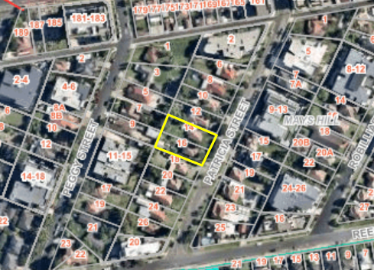

*Figure 5 – Local Area catchment*

Step 2 – Determine the character (present and future) of the local area.

The zoning of the broader locality and immediate area comprises R4 High Density Residential under the Cumberland Local Environmental Plan (CLEP) 2021.

*Present Character of the area*

The character of the local area comprises the visual catchment of regular shaped allotments viewed from and surrounding the subject site, which includes a mixture of building types including residential flat buildings from 2 to 4 storeys in height and single to double storey dwellings.

*Figure 6: Existing Streetscapes*

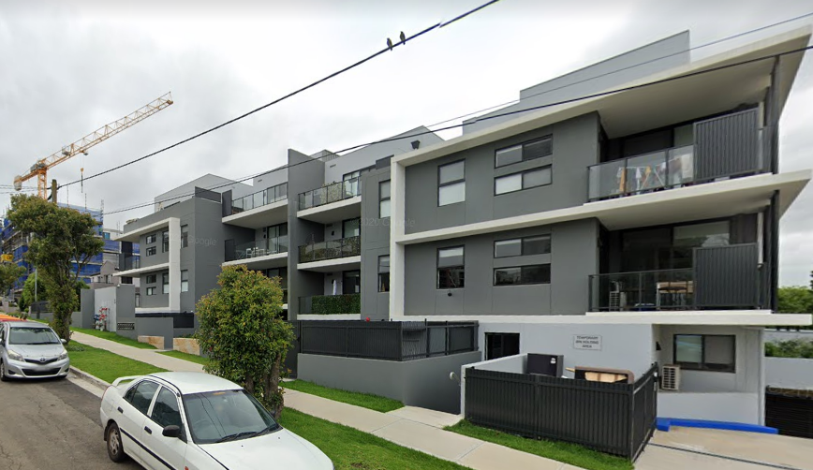 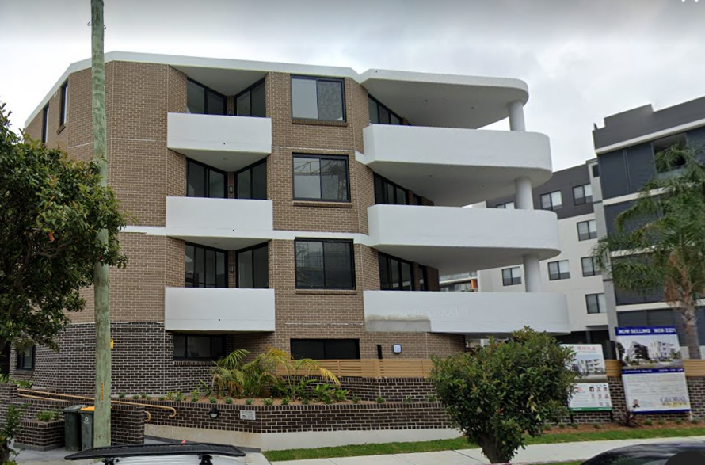

9-13 Patricia Street 2 Patricia Street

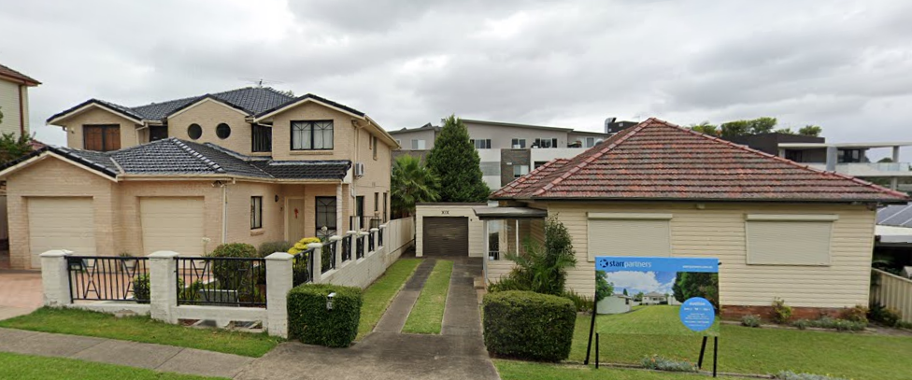

17 & 19 Patricia Street

*Future Character of the area*

The locality is in transition particularly to support the increasing demand of affordable housing within the close proximity of public transport on the Parramatta Transitway and commercial centre on Great Western Highway. The transition issue is clear with regard to FSR, height and setbacks for the proposed development. It is considered that the height, bulk and scale of the proposed development is consistent with the newer approved residential flat buildings being constructed and would not be inconsistent with the desired future character of the locality.

Step 3 - Determine if the development is compatible with the character of the local area.

In accordance with the Land and Environment Court’s ‘Planning Principle’ and case law compatibility is best defined as ‘capable of existing together in harmony’. In order to test compatibility two questions are to be considered. These questions, as well as a response to each, are provided below:

* *Are the proposal’s physical impacts on surrounding development acceptable? The physical impacts include constraints on the development potential of surrounding sites.*

The height, FSR and landscaping of the proposed development are designed to maintain the harmony within the streetscape, whilst contributing to the site context and constraint. The proposal being a permissible land use, meets the building height and FSR requirements and contributes to the provision of affordable housing within the close proximity of public transport and commercial centre. The development does not pose any unreasonable overshadowing impacts on adjoining properties.

The proposed development is similar to residential flat buildings approved on 1 Peggy Street and 3-9 Peggy Street, and constructed on 2 Patricia Street, 5 Patricia Street, 9-13 Patricia Street, 4-6 Peggy Street, 11-15 Peggy Street, 8-12 Robilliard Street and 24-26 Robilliard Street.

Whilst the development will result in some overshadowing to the adjoining properties on the side boundaries, the impacts are not considered unreasonable given this is a function of the allotment orientation and R4 context. The overall design represents the form of development that is envisaged under the planning controls. Refer to further discussion under DCP section of the report.

* *Is the proposal’s appearance in harmony with the buildings around it and the character of the street?*

To be compatible, a development should contain, or at least respond to the key aesthetic elements that make up the character of the surrounding area. The size of the basement with variation to the side setbacks maximises landscaping and deep soil zones on site. The front setbacks are generous and consistent with the existing streetscape. The proposal is considered to maintain an appropriate residential character which is consistent with the emerging character of the streetscape. As indicated, the local area has some established high density residential built form, as such, the proposed development is not considered to be inconsistent with the desired and future streetscape character of the immediate area surrounding the subject site.

In conclusion, the proposal will maintain the harmony within the general streetscape, and suitably fits in the local character of the locality.

1. **Statement Environmental Planning Policy (Housing) 2021 (Housing SEPP)**

The Housing SEPP 2021 was published on the NSW Legislation website on 26 November 2021 and has commenced as of that date, which repeals the ARH SEPP 2009. The Housing SEPP includes schedule 7A (Savings and transitional provisions), which states that this SEPP does not apply if a DA was lodged with Council however has been not determined prior to the commencement of this SEPP. The current DA was accepted by Council on 16 November 2021 pursuant to the provisions of ARH SEPP.

The provisions of the Housing SEPP have also been considered in the assessment of this application and are found to be satisfactory and not inconsistent with the proposed assessment under the ARH SEPP as stated above. The period of use for the affordable housing component of the development under the Housing SEPP has increased to 15 years, as it was capped as 10 years under the ARH SEPP. This is not a matter of concern of the assessment of this application, as the land is owned by the LAHC and all of the residential development is taken, for the purpose of the policy, to be used as affordable housing.

1. **Statement Environmental Planning Policy No. 65 -** [**Design Quality of Residential Apartment Development**](http://www.legislation.nsw.gov.au/#/view/EPI/2002/530) **(SEPP 65)**

SEPP 65 applies to the development as the building is 3 storeys or more and contains more than 4 dwellings. A design statement addressing the design quality principles prescribed by SEPP 65 was prepared by the project architect. Integral to SEPP 65 is the Apartment Design Guide (ADG), which sets benchmarks for the appearance, acceptable impacts and residential amenity of the development.

A comprehensive assessment against the SEPP 65 and Apartment Design Guide (ADG) controls is provided at Attachment 7.

The proposal involves the following non-compliance with the ADG controls:

* **3D Communal and public open space**

Objective 3D-1 of the ADG states that developments shall achieve a minimum of 50% direct sunlight to the principal useable part of the communal open space (COS) for a minimum of 2 hours between 9am and 3pm at mid-winter. Despite providing a COS area exceeding the minimum requirement, only 139m² (39.8%) of the minimum required COS size (348.5m²) will receive 50% direct sunlight to the principal useable part of the communal open space (COS) for a minimum of 2 hours between 9am and 3pm at mid-winter. Non-compliance with the solar access requirement is not considered unreasonable and it is supported in this instance given that the site is constrained by its east to west orientation. Furthermore it is noted that most of the units have reasonably sized balconies and the site is located within 100m walking distance to a public park.

* **3F Visual Privacy**

Objective 3F-1 of the ADG states that minimum separation distances from buildings to side and rear boundaries are as follows.

|  |  |  |
| --- | --- | --- |
| Building (height) | Habitable rooms and balconies | Non-habitable rooms |
| Up to 12m (4 storeys) | 6m | 3m |

The proposal generally complies with the building separation requirements with the exception of ground floor north, west and south facing POS and bedroom windows, and level 1-3 north and south facing bedroom windows. Notwithstanding this, fixed privacy screens are proposed to all of the non-compliant POS and bedroom windows, with exception of south facing POS of apartment G-01. Additional condition is to be imposed for the south facing POS of apartment G-01 to be provided with privacy screen with height 1.5m above the finished floor level, which is considered satisfactory to maintain reasonable privacy with the adjoining properties.

* **4A Solar and daylight access**

Design criteria of 4A-1 of the ADG states that living rooms and private open spaces of at least 70% (20.3/29) of the apartments in a building shall receive a minimum 2 hours direct sunlight between 9am and 3pm at mid-winter. On the contrary, the proposal results in 69% (20/29) of the apartments in a building to receive a minimum 2 hours direct sunlight between 9am and 3pm at mid-winter, resulting in a variation of 0.3 that is rounded up to 1 unit.

As discussed earlier in the report, the non-compliance is mainly due to the orientation of the site and the proposal is largely consistent with the ADG design criteria and guidance for apartments as only 3.5% (1) of the apartments is affected to achieve the 70% strict compliance.

* **4E Private open space and balconies**

Design criteria of 4E-1 of the ADG states that for apartments at ground level on a podium, a private open space (POS) is provided instead of a balcony with a minimum area of 15m² and a minimum depth of 3m. Apartment G-05 has been provided with a balcony instead of a courtyard with an area of 10m², as the finished floor level of this ground floor apartment is 0.5m above the natural ground level. The shortfall in the size of POS is considered acceptable, as the balcony is located within the front setback and may interfere with the provision of disabled ramp if to be redesigned for a strict numerical compliance. The apartment has direct access to the COS area. Minor non-compliance with the internal POS size of the apartment is therefore supported in this instance.

1. **State Environmental Planning Policy (Biodiversity and Conservation) 2021**

Chapter 2 –Vegetation in non-rural Areas

The proposed trees to be removed does not hold biodiversity values.

Chapter 6 – Bushland in Urban Areas

The proposal does not propose to disturb bushland zoned or reserved for public open space.

Chapter 10 – Sydney Harbour Catchment

The subject site is identified as being located within the area affected by the Sydney Harbour Catchment provision. The proposed development raises no issues as no impact on the catchment is envisaged.

1. **State Environmental Planning Policy (Transport and Infrastructure) 2021**

Chapter 2 – Infrastructure

The provisions of the Transport and Infrastructure SEPP have been considered in the assessment of the development application. Pursuant to Clause 2.48 the associated works are proposed to be carried out within the vicinity of an easement for electricity benefitting Endeavour Energy.

In accordance with Clause 2.48 the application was referred to Endeavour Energy as an existing padmount station is located on the site. Endeavour Energy has advised that the site is not burdened by an easement benefitting Endeavour Energy, however the substation and the underground cables are protected works under Section 53 ‘Protection of certain electricity works’ of the *Electricity Supply Act* 1995 (NSW). Endeavour Energy has reviewed the proposed works and is raising no objection to the proposal subject to conditional requirements noting compliance with the requirements of Endeavour Energy.

1. [**State Environmental Planning Policy (Building Sustainability Index: BASIX) 2004**](https://www.legislation.nsw.gov.au/#/view/EPI/2004/396)

BASIX certificate no. 1234004M_02 dated 25 October 2021 was submitted with the application. The certificate achieves target scores and is consistent with the architectural plans.

Local Environmental Plans

**Cumberland Local Environmental Plan (CLEP) 2021**

The provision of the Cumberland LEP 2021 is applicable to the development proposal. It is noted that the development achieves compliance with the key statutory requirements of the Cumberland LEP 2021 and the objectives of the R4 – High Density Residential zone.

1. **Permissibility:**

The proposed development is defined as a ‘residential flat building’ under the provisions of Cumberland LEP 2021. Residential flat buildings are permitted with consent in the R4 – High Density Residential zone which applies to the land.

***residential flat building*** means a building containing 3 or more dwellings, but does not include an attached dwelling or multi dwelling housing.

**Note—**

Residential flat buildings are a type of ***residential accommodation***—see the definition of that term in this Dictionary.

The relevant matters to be considered under CLEP 2021 and the applicable clauses for the proposed development are summarised below. A comprehensive LEP assessment is contained in Attachment 8.

Figure 7 – Cumberland LEP 2021 Compliance Table

| **Development Standard(s)** | **Proposal** | **Compliance** |
| --- | --- | --- |
| **Clause 4.1**  Minimum Subdivision Size  900m² | 1,394m² | Yes |
| **Clause 4.3**  Height of Buildings  15m | * + 14.3m | Yes |
| **Clause 4.4**  Floor Space Ratio  1.2:1 + 0.5:1 (ARH SEPP)  = 1.7:1 | 1.63:1 or GFA of 2276m² (including ARH SEPP bonus) | Yes |
| **Clause 6.7**  Stormwater Management | The proposed stormwater management has been reviewed by Council, which is considered satisfactory subject to condition. | Yes |
| **Clause 6.9**  Salinity  Potential Moderate Salinity | Subject to condition. | Yes |
| **Clause 6.12**  Urban Heat | The development accommodates sufficient tree canopy, open space and deep soil zones to achieve urban cooling benefits. | Yes |

**The provisions of any proposed instrument that is or has been the subject (EP&A Act s4.15 (1)(a)(ii))**

**Draft State Environmental Planning Policy (Design and Place)**

The draft SEPP Design and Place as exhibited aims to simplify and consolidate how to address the need for sustainable and resilient places and deliver good design in NSW.

The changes proposed include consolidating the following existing SEPPs:

* SEPP 65 – Design Quality of Residential Apartment Development
* SEPP (Building Sustainability Index: BASIX) 2004

For the purposes of section 4.15(1)(a)(ii) of the Environmental Planning and Assessment Act 1979 (EP&A Act), the draft proposed State Environmental Planning Policy (Design and Place) 2021 is not notified to any consent authorities and so is not a mandatory matter for consideration under section 4.15 of the EP&A Act.

**The provisions of any Development Control Plans (EP&A Act s4.15 (1)(a)(iii))**

The proposed development complies with the provisions of Council’s Cumberland Development Control Plan (CDCP) 2021, with the exception of adaptable units and disabled car spaces as discussed below, and is considered acceptable from an environmental planning view point. A comprehensive DCP assessment is contained in Attachment 9.

**Part B5 – Adaptable housing**

The Cumberland DCP 2021 requires a minimum of 20% of units (or 5.8~6 units) to be provided as adaptable. The proposed development however proposes 4 adaptable housing units including:

• 1 x adaptable 1 bedroom unit

• 2 x adaptable 2 bedroom units

• 1 x adaptable 3 bedroom unit

Four (4) adaptable car parking spaces are also provided corresponding with the number of adaptable units proposed.

Based on the above, the proposal results in shortfall of 2 (13.8%) of adaptable units and disabled car spaces.

Notwithstanding this, the non-compliance to the adaptable housing and car parking provision is considered acceptable as 100% of the units will be designed to achieve a Silver Rating as per the Liveable Housing Design Guidelines. On this basis, the proposal is highly accessible. Furthermore, LAHC has indicated that it holds within its portfolio approximately 6.9% of accommodation within the Cumberland LGA, which enables it to allocate housing based on suitability to address tenant needs. The variety of existing accommodation and proposed future development gives LAHC flexibility to accommodate tenants who may require adaptable or accessible accommodation or transport.

**The provisions of any planning agreement that has been entered into under section 7.4, or any draft planning agreement that a developer has offered to enter into under section 7.4 (EP&A Act s4.15(1)(a)(iiia))**

There is no draft planning agreement associated with the subject Development Application.

**The provisions of the Regulations (EP&A Act s4.15 (1)(a)(iv))**

The proposed development raises no concerns as to the relevant matters arising from the *Environmental Planning and Assessment Regulations 2000* (2021 Regulation). The[*Environmental Planning and Assessment Regulation 2021* (2021 Regulation)](https://legislation.nsw.gov.au/view/html/inforce/current/sl-2021-0759)commenced on**1 March 2022**andreplaced the 2000 Regulation*.* The 2000 Regulation continues to apply instead of the 2021 Regulation as the subject development application was made but not finally determined before 1 March 2022 in accordance with Schedule 6 Savings Transitional and other provisions of the 2021 Regulation.

**The Likely Environmental, Social or Economic Impacts (EP&A Act s4.15 (1)(b))**

It is considered that the proposed development will have no significant adverse environmental, social or economic impacts in the locality.

**The suitability of the site for the development (EP&A Act s4.15 (1)(c))**

The subject site and locality is not known to be affected by any natural hazards or other site constraints likely to have a significant adverse impact on the proposed development. Accordingly, it is considered that the development is suitable in the context of the site and surrounding locality.

**Submissions made in accordance with the Act or Regulation (EP&A Act s4.15 (1)(d))**

|  |  |  |  |
| --- | --- | --- | --- |
| Advertised (Website) | Mail | Sign | Not Required |

In accordance with Council’s Notification requirements contained within the Cumberland DCP 2021, the proposal was publicly notified for a period of 14 days between 3 December 2021 and 17 December 2021. The notification generated nil submission in respect of the proposal with none disclosing a political donation or gift.

**The public interest (EP&A Act s4.15(1)(e))**

In view of the foregoing analysis it is considered that the development, if carried out subject to the conditions set out in the recommendation below, will have no significant adverse impacts on the public interest.

CUMBERLAND LOCAL INFRASTRUCTURE CONTRIBUTIONS PLAN 2020

The development would not require the payment of contributions in accordance with Cumberland Local Infrastructure Contributions Plan 2020.

Disclosure of Political Donations and Gifts

The applicant and notification process did not result in any disclosure of Political Donations and Gifts.

Conclusion

The proposed development is appropriately located within the R4 High Density Residential zone under the relevant provisions of the Cumberland LEP 2021. The proposal is consistent with all statutory and non-statutory controls applying to the development. Non-compliances with Council’s controls have been discussed in the body of this report. The development is considered to perform adequately in terms of its relationship to its surrounding built and natural environment, particularly having regard to impacts on adjoining properties.

For these reasons, it is considered that the proposal is satisfactory having regard to the matters of consideration under Section 4.15 of the *Environmental Planning and Assessment Act 1979*, and the development may be approved subject to conditions.

RECOMMENDATION

1. **That Development Application No. DA2021/0636** **for demolition of existing structures and construction of a four storey residential flat building containing 29 affordable housing units over one level of basement parking pursuant to State Environmental Planning Policy (Affordable Rental Housing) 2009** **on land at 14 Patricia Street MAYS HILL NSW 2145** **be approved subject to the conditions as recommended in the Council’s assessment report.**

**ATTACHMENTS**

1. Draft Notice of Determination

2. Architectural Plans

3. Landscape Plans

4. Shadow Diagram

5. Stormwater/Engineering Plans

6. ARH SEPP

7. SEPP 65 & ADG Assessment

8. Cumberland LEP Assessment

9. Cumberland DCP Assessment